# Assignment No:8

Practical Exercise: Backward Chaining Algorithm

## 1) Problem Statement

Implement the Backward Chaining algorithm to infer if a particular goal can be achieved based on known facts and a set of rules. Backward Chaining is a reasoning method where the system works backward from the goal, looking at the rules to find conditions that must be true to achieve the goal.

## 2) Libraries Used

Python:  
1. **Dictionary Data Structure**: Used to represent rules and facts for reasoning.

## 3) Theory

Backward Chaining is a goal-driven reasoning method used in expert systems. The process starts with the goal and works backward through the rules to check if the goal can be achieved. If the conditions for a rule are not met, the algorithm recursively checks the conditions of the conditions, continuing this process until a base fact is found or until the goal cannot be achieved.  
  
In this method, we aim to prove the truth of the goal by proving the truth of all the conditions needed to derive the goal.

## 4) Methods

1. **Rules Representation**: The rules are represented as a dictionary where the key is a conclusion, and the value is a list of conditions required for the conclusion to be true.  
2. **Facts Representation**: Facts are represented as a set of known truths.  
3. **Backward Chaining Algorithm**:  
 - The algorithm starts by checking if the goal is already a known fact.  
 - If the goal is not a fact, it looks for rules that lead to the goal and checks if the conditions of those rules are satisfied.  
 - The algorithm recursively checks the conditions until it either finds that the goal can be achieved or that it cannot.

**5) Diagram**

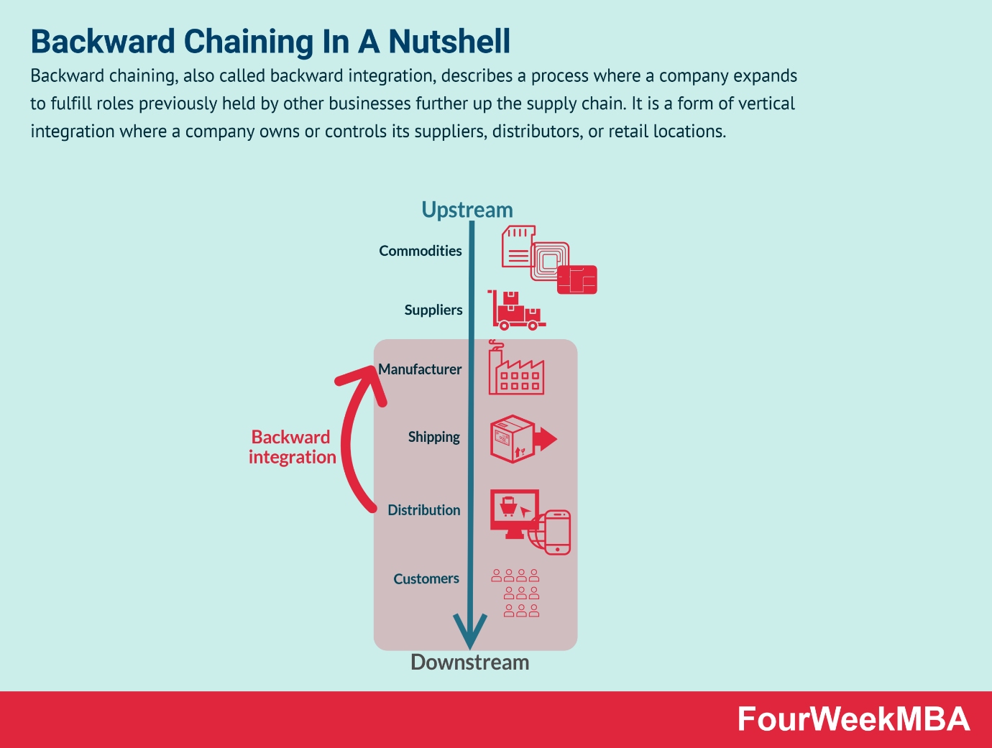

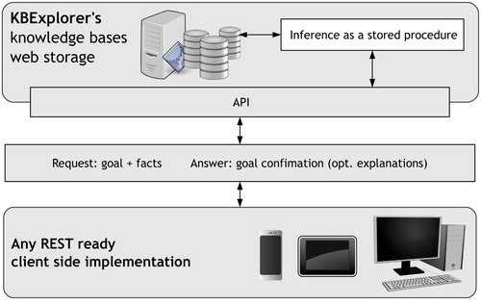

## 6) Advantages and Disadvantages

- **Advantages**: Backward Chaining is efficient in goal-driven reasoning, as it only evaluates rules that are relevant to the goal. It is suitable for situations where the goal is known, and the system needs to verify if it can be achieved.  
- **Disadvantages**: Backward Chaining can be inefficient if there are many conditions and rules that need to be checked recursively. Additionally, it may fail if there are circular dependencies between rules.

**7) Conclusion**

The **Backward Chaining Algorithm** is a powerful technique for deriving conclusions from a set of known facts and rules in artificial intelligence. This implementation demonstrates its utility in rule-based systems and shows how it can be used to prove a specific goal by recursively checking the conditions that support it. Backward chaining's efficiency in goal-directed reasoning makes it an essential tool for various applications in AI, particularly in expert systems where the outcome is predetermined, and supporting knowledge needs to be identified.